**FREE ONLINE ESCAPE ROOM GAMES**

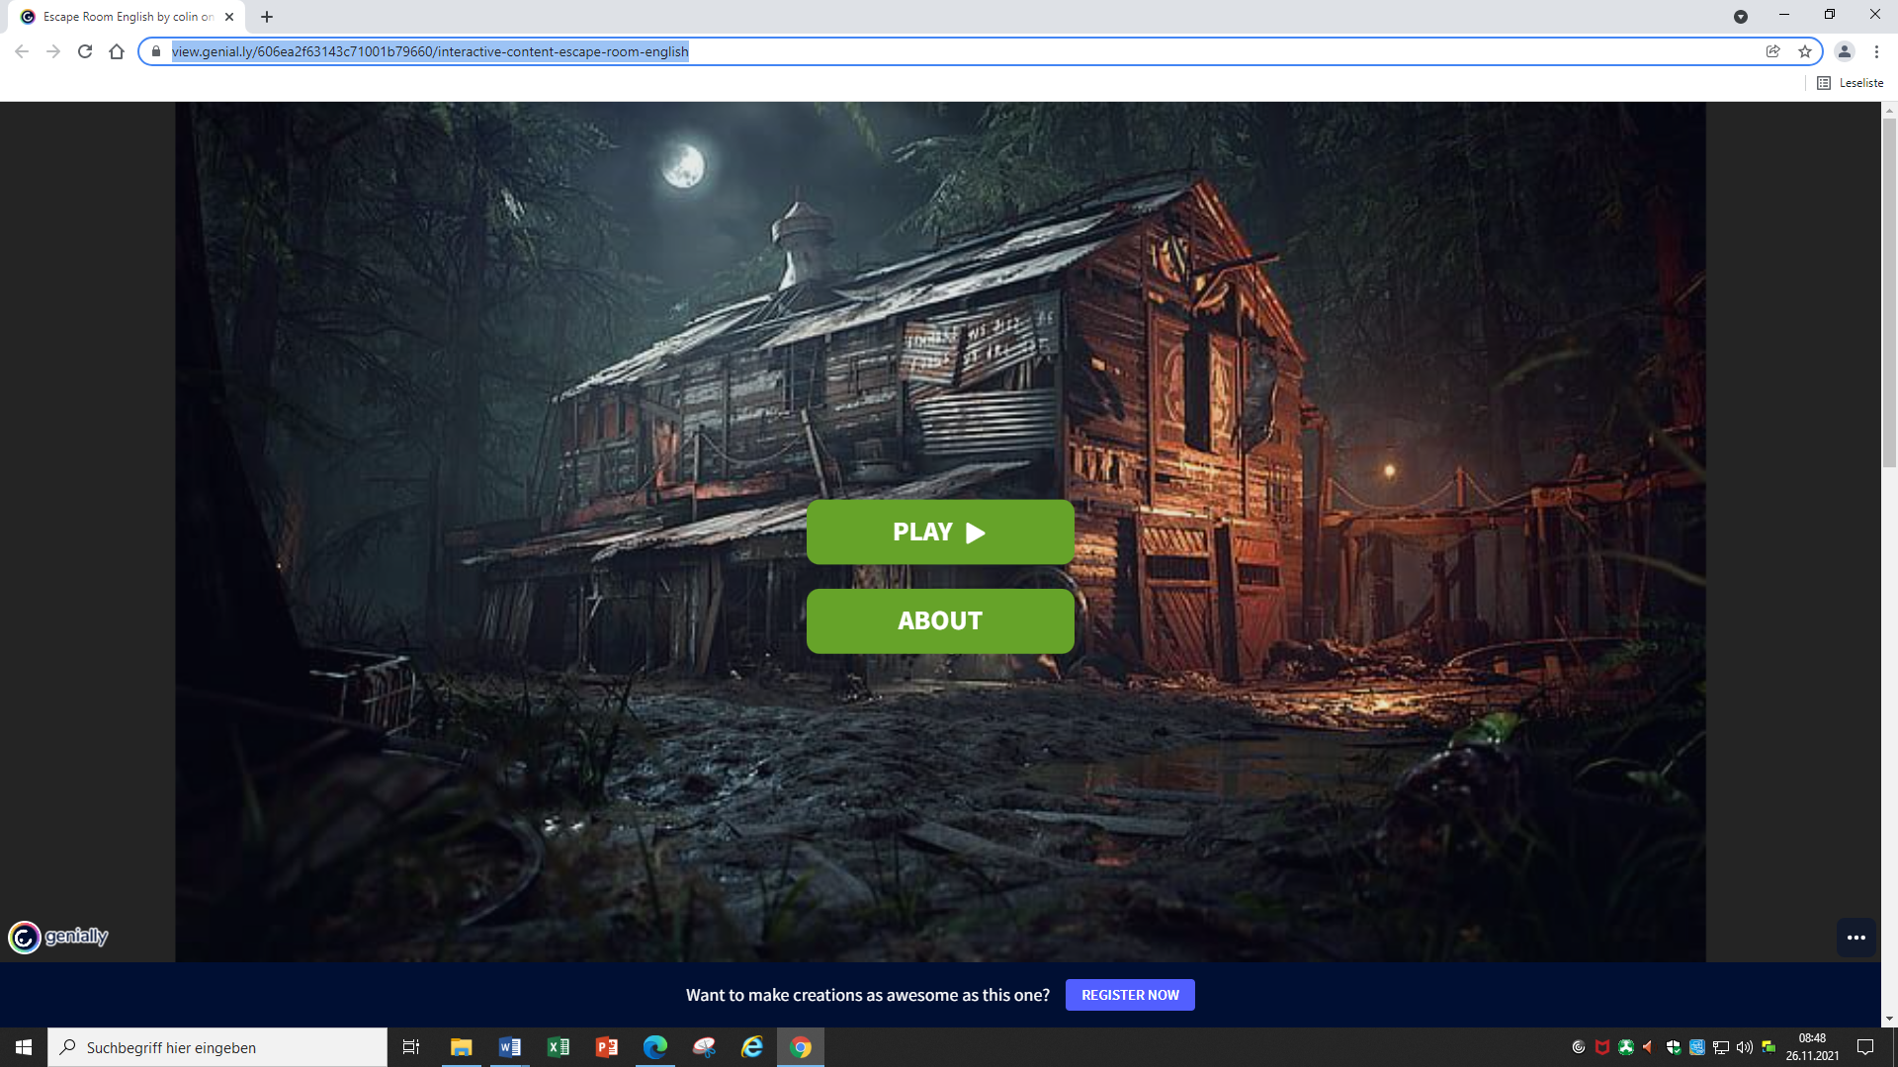**MURDERER IN THE HOUSE**

While investigating a murder case in an abandoned house, you accidentally step on a trigger to a lock room causing every exit you found is locked from the outside. However, you managed to find a door that may be opened from the inside. The only problem is, you need to find the secret code left by the murderer to unlock the door. Find your way out before the killer finds you.

<https://view.genial.ly/606ea2f63143c71001b79660/interactive-content-escape-room-english>

**HOGWARTS DIGITAL ESCAPE ROOM**

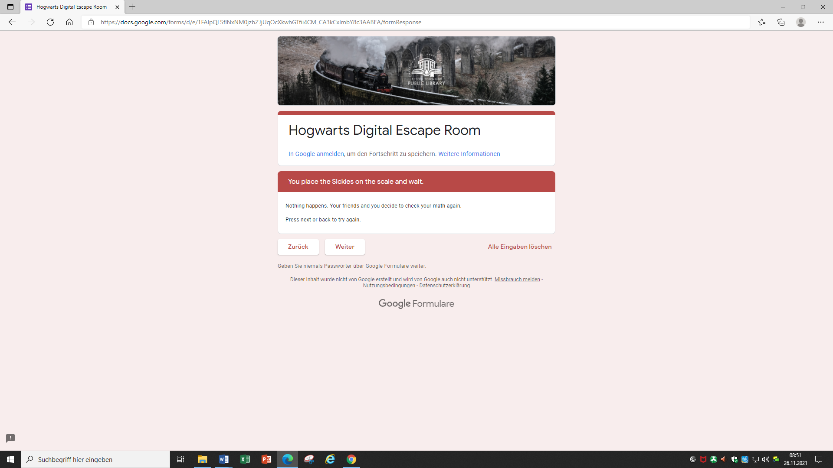The story starts when you receive your long awaited Hogwarts letter. On your way to school you make a new friend, who fits in well with your friend group. One afternoon you discover that she has disappeared. Could this have anything to do with her biggest secret? Can you figure out what happened to her?

<https://docs.google.com/forms/d/e/1FAIpQLSflNxNM0jzbZJjUqOcXkwhGTfii4CM_CA3kCxImbY8c3AABEA/viewform>

**ESCAPE FROM ALCATRAZ ISLAND**

"Escape From Alcatraz Island" is a point and click type of escape game played online. You can play it on your own or have a team on the back end giving suggestions. There's no time limit so enjoy it at your own pace. We completed the game individually and it took about 20 minutes or so. I got stuck on one puzzle as i didn't "expect" that to be the solution as it's uncommon in the US. I did enjoyed the humor that was added into the script. I can't wait to see where this escaped convict goes next and we'll be happy to be his partner in crime again! 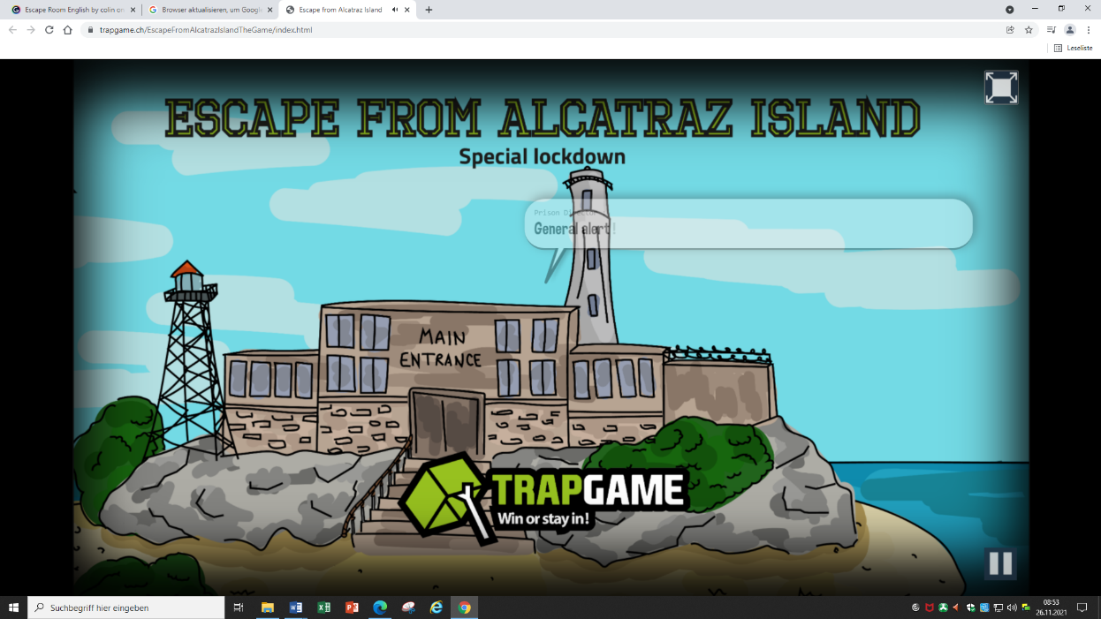

<https://www.trapgame.ch/EscapeFromAlcatrazIslandTheGame/index.html>

**EGYPTIAN ESCAPE PUZZLE**

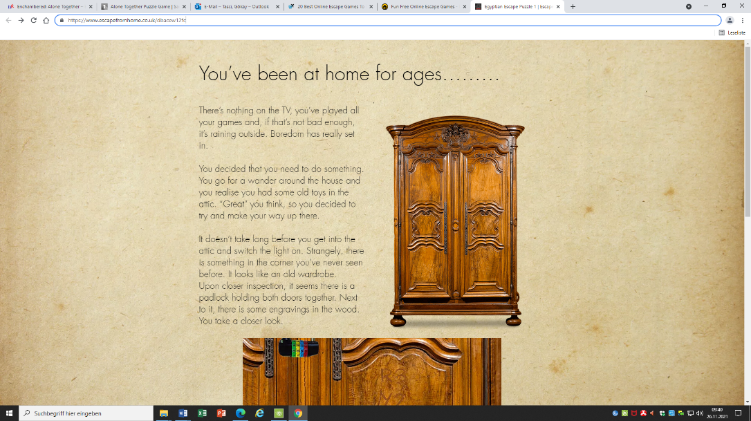There’s nothing on the TV, you’ve played all your games and, if that’s not bad enough, it’s raining outside. Boredom has really set in. You decided that you need to do something. You go for a wander around the house and you realise you had some old toys in the attic. “Great” you think, so you decided to try and make your way up there. It doesn’t take long before you get into the attic and switch the light on. Strangely, there is something in the corner you’ve never seen before. It looks like an old wardrobe…

<https://www.escapefromhome.co.uk/dbacew12fc>

**ALONE TOGETHER**

Play with a friend! Can you decipher enigmatic puzzles that require constant communication between you and your teammate to solve? Your escape is dependent on how well you work together to find your way through gadgets and clues to solve the puzzle. Using two separate devices, play with a friend on the couch or even all the way across the globe on the phone or video chat!

<https://www.enchambered.com/puzzles/alone-together/>

**MARTY AND THE THIEF IN THE NIGHT**

Marty the Guard Dog has solicited your help in uncovering who robbed his house last night. Can you figure out WHERE they stole something, WHAT they stole, WHEN they stole it, and ultimately WHO they were?

<https://totalescapegame.com/woof>

**LAB**

Immerse yourself into the mystery of a free escape room: the mad scientist's laboratory. The scientists discovered the cure for all viruses but was captured and sent to mental health facility after false allegations from his rivaling scientists. He hid the formula in a secret place that you can find. Hurry up, you only have 30 minutes!

<https://freerooms.co.uk/escape-room-mad-scientist>